Kootenai Shoshone Soil and Water Conservation District
7830 Meadowlark Way, Ste. C-1
Coeur d'Alene ID 83815
208.209-4348

“Putting conservation on the ground by promoting stewardship”

Minutes

Date: December 11, 2024

Present Absent (Board members)

Laurin Scarcello – Chairman
Linda Ely – Vice – Chairman
Wes Evans – Secretary/Treasurer
Bob Flagor, Associate Supervisor
Jon Groth – Supervisor
Kevin Hicks - Supervisor
John Mobbs – Associate Supervisor
Joel Noland - Supervisor
Kevin Hicks – Supervisor
Thomas Shafer- Supervisor
Karla Freeman, KSSWCD
Corey Bonsen- NRCS
Jenna Ditzel – ISWCC
Paul Mallow
Richard Meyer
David Muise – KEA
Bob Burke – Landowner
Kelli Moe- Boat Station Manager

The meeting was held at the NRCS Conference Room located at 7830 Meadowlark Way Suite C-1, Coeur d’Alene, ID 83815.

Meeting called to order by Chairman Laurin Scarcello at 9:00 am.

Linda Ely moved, and Jon Groth seconded the motion to approve October’s 2024 meeting minutes. MOTION CARRIED.

Joel Noland moved, and Linda Ely seconded the motion to approve October’s and November’s financial report with one edit on the reimbursement check to John Mobbs to change the category for the expense. MOTION CARRIED. Joel Noland suggested that the district investigate investing some of the additional funds in the bank account to earn increased interest rates.

Next on the agenda was Corey Bonsen, NRCS.

Staffing and Office
- Our new Administrative Assistant is Zachery Burkey. Zach will start on Monday December 16th in the Coeur d’Alene office. Please help us welcome Zach. He will be going to both offices helping with filing etc, until he can get computer access.

Environmental Quality Incentives Program (EQIP)
- We are currently working on ranking our Fiscal Year 2025 EQIP applications.

- We have 79 eligible applications at this point.

- With the state deciding to keep the Inflation Reduction Act (IRA) funds as Act Now, these deadlines are a bit misleading. Landowners with qualifying practices can sign up through March 7th and still be considered for FY25 funding in most fund pools.

- The EQIP sign up 2 deadline is April 4th, however it is limited to specific pools.
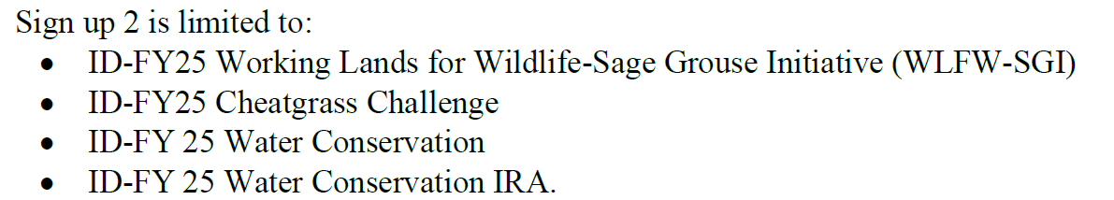

Conservation Stewardship Program (CSP)
- We had one CSP renewal application. It has been assessed, ranked, and is ready for obligation.

- The CSP general sign up is on right now through February 28th.
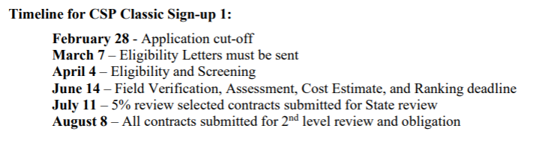

Civil Rights –

- As always, board members are welcomed to request civil rights training from NRCS.

Next on the agenda is Jenna Ditzel, ISWCC.

Agency Report
- ISWCC Commissioners’ Meeting at 9 a.m PT on 12/12.
Agenda:
  - A discussion on how Commission board members and staff can interact appropriately with legislators.
  - Employee Engagement Survey results and action plan.
  - Additional information regarding implementation of TMDLs. This will build upon the TMDL discussion Commissioners had during their September meeting.
- Administrative Staff are preparing for the 2025 Legislative Session
  - Staff are working with the Governor’s Office, the Legislative Services Office, and the Division of Financial Management to prepare and submit the annual reports we are required to present before various committees of the Legislature.
  - Staff are also working to schedule Senate confirmation hearings for the two Commissioners, Karen Sharpnack from Division IV and Erik Olson from Division I—who the Governor recently reappointed to new 5-year terms on our board.
Other Updates
- U of I Selkirk Local Food Summit (11/8) recap
  - Idaho Business Builder Grant Opportunity due 1/15/25
- Farm & Food Symposium (11/12 – 11/14) recap
  - Lots of good conversation about soil health, transparency in the food supply, nutrient density, etc…
Upcoming Dates
- Performance Report is due 12/20

Next on the agenda is Karla Freeman, District Administrator:

Karla updated on the following projects:

Toedter – Project has been completed; we will be doing some summertime monitoring. Currently working on the final report to be submitted next summer after the monitoring is completed.

Wolf Lodge Creek #5 – Andrew LeClaire- Sandy is continuing with the willow plantings.

Albert Walsh – Completed project and have submitted the final report to DEQ.

Boat Stations – All are closed, and we have Kelli Moe, Boat Station manager here to give us a season wrap up.
Outreach Event – School Event in Spirit Lake on December 17th. Wes Evans, John Mobbs, Jenna Ditzel and I will be attending this.

Next on the agenda was the resignation of current board member Thomas Shafer, his resignation will be effective January 1, 2025. Thomas is resigning due to time constraints with holding a seat on two boards. Thomas indicated that he would like to stay involved with the district as an associate board member.

Next on the agenda is the action item to appoint someone to fill the vacant seat from Thomas Shafer. Discussions around the room were had in favor of appointing Laurin Scarcello to fill the remaining term for Thomas Shafer. The term will expire on December 31, 2026. Discussions were had around the room in this favor. Linda Ely moved, and Kevin Hick seconded the motion. MOTION CARRIED.

Next on the agenda is the action item to elect new board officer seats. Joel Noland showed interest in taking on the responsibility of board Chairman. Discussions were had around the room, it was decided that with the years of service and experience Laurin Scarcello has, he should continue to hold this seat. Wes Evans, moved, and Thomas Shafer seconded the motion. MOTION CARRIED. Wes Evans, Supervisor moved, and Linda Ely seconded the motion to have Jon Groth, hold the seat of Vice-Chairman. MOTION CARRIED. Kevin Hicks moved, and Joel Noland seconded the motion to have Wes Evans keep his seat as treasurer. MOTION CARRIED. All new officer seats will be effective January 1, 2025.

Next on the agenda is the action item to appoint new associate board members, Linda Ely and Thomas Shafer have both agreed to hold seats as an Associate Supervisor. Joel Noland moved, and Kevin Hicks seconded the motion. MOTION CARRIED.

Next on the agenda is the discussion topic of the importance of board attendance and participation in daily and weekly tasks that are needed from Karla Freeman, District Administrator such as signing checks, MOU’s or anything she needs a signature on. Joel Noland suggested that the district look at maybe rescheduling the time slot for the monthly board meetings since several members hold full time jobs. This will be a topic on the January 2025 agenda.

Next on the agenda is just to go over who will be the new signatures on the bank account at Idaho Central Credit Union. There are two new board members that will be on the signature card as they were voted in at the last election. The following are the members to be effective January 1, 2025, with the seat that they hold:

Laurin Scarcello – Chairman
Jon Groth – Vice-Chairman
Wes Evans – Treasurer/Secretary
Kevin Hicks – Supervisor
Joel Noland – Supervisor
Paul Mahlow- Supervisor
Richard Meyer- Supervisor

Next on the agenda was an update from Kelli Moe, Boat Station Manager. Kelli updated on the season end wrap up with the statistics of all 4 stations as well as obstacles encountered throughout the season and how we can better address these. Signage is an ongoing issue at all stations. We need larger signs as well as look into the possibility of moving them before the exits or pull-offs. This concern will be addressed with the Department of Agriculture since they are the agency responsible for the signage. Another concern is the cell service and coverage at the boat stations, we will address maybe installing hotspots or signal boosters. We will also discuss obtaining additional educational handouts for the inspectors to give out.

Next on the agenda was the discussion item brought forward from Thomas Shafer about the Kootenai County Commissioners request for applications to volunteer to sit on a new board that is being formed called the Agricultural Protection Board. Discussions were had about the leverage and impact this board could have on the community. We were able to have Laurin Scarcello volunteer to sit on this board and his application has been submitted. Linda Ely and Kevin Hicks both showed interest volunteering for this as well.

Next on the agenda was the request for sponsorship of the Post Falls STEM Charter Team. We have sponsored this team for the last 4 years. Wes Evans moved, and Joel Noland seconded the motion of a $500.00 sponsorship for the STEM Charter Team. MOTION CARRIED.
Next on the agenda were updates on the Kinston Sewer and Water Project from Jon Groth, The Kingston Sewer and Water land project is continuing to move forward, the bids were opened and scored by the board. Bids came in over the anticipated budget. They plan on going back to DEQ to see if there are additional funds that can be used for this project. Jon has also brought to the board a possible project that would be a great 319 grant proposal. The project is in the Silver Valley and would be very similar to the Wolf Lodge Creek Reach # 3 project of diverting the channel. Karla, Jenna and Bill will reach out to the landowner and start the process of a possible grant application.

Next meeting will be on Wednesday January 8, 2025, at 9:00 am.

The meeting adjourned at 11:15 am.

